**Assignment no.1**

Module–1 (Fundamental)

* What is SDLC?

SDLC is a structural process used by the software industry to design, development and test high Quality software, SDLC aims to produce high quality software that meets customer expectations.

• What is agile methodology?

* Agile SDLC model is a combination of iterative & incremental process model with focused on process adaptability & customer satisfaction.
* Agile model break the product into small incremental builds.
* These build are provided in iteration.

• What is SRS?

A software requirement specification (SRS) is a complete description of the behavior of the system to

Be developed.

• What is oops?

* Identifying Object and assigning responsibilities to these objects.
* An object like a black box.
* The internal details are hidden.
* Object communicates to other by sending message.

• Write Basic Concepts of oops

1. Object.
2. Class.
3. Encapsulation.
4. Inheritances.
5. Polymorphism.
6. Abstraction.

• What is object?

Instances of a class.

To access all the properties of a class except private I.e. locker, mobile etc…

• What is class?

Class is an collection of data member (variable), member function (process member) with it’s

Behavior. I.e. class room, car etc…

• What is encapsulation?

Wrapping up of data into single unit that called encapsulation.

Private your data member or member function.

• What is inheritance?

Properties of parent class (one class) extend to child class (second class).

* **There are 5 types of Inheritances:-**
* Single
* Multilevel
* Hierarchical
* Multiple
* Hybrid

• What is polymorphism?

Ability to take one name having different form.

**There are 2 types:-**

1. Method overloading
2. Method overriding.

• What is RDBMS?

A database management system (DBMS) that incorporate the relational data model normally including

a structured query (SQL) application programming interface.

It is a DBMS in which the database is organized and accessed according to the relationship between

data items.

• What is SQL?

SQL is a domain specific language used in programming and design for managing data held in

relational data base management system (RDBMS).

• Write SQL Commands?

There are **4 types** of commands,

1. DDL – Data Definition language.
2. DML – Data manipulation language.
3. DQL – Data Query language.
4. DCL / TCL – Data/Transactional control language.

• Draw Use case on online book shopping.

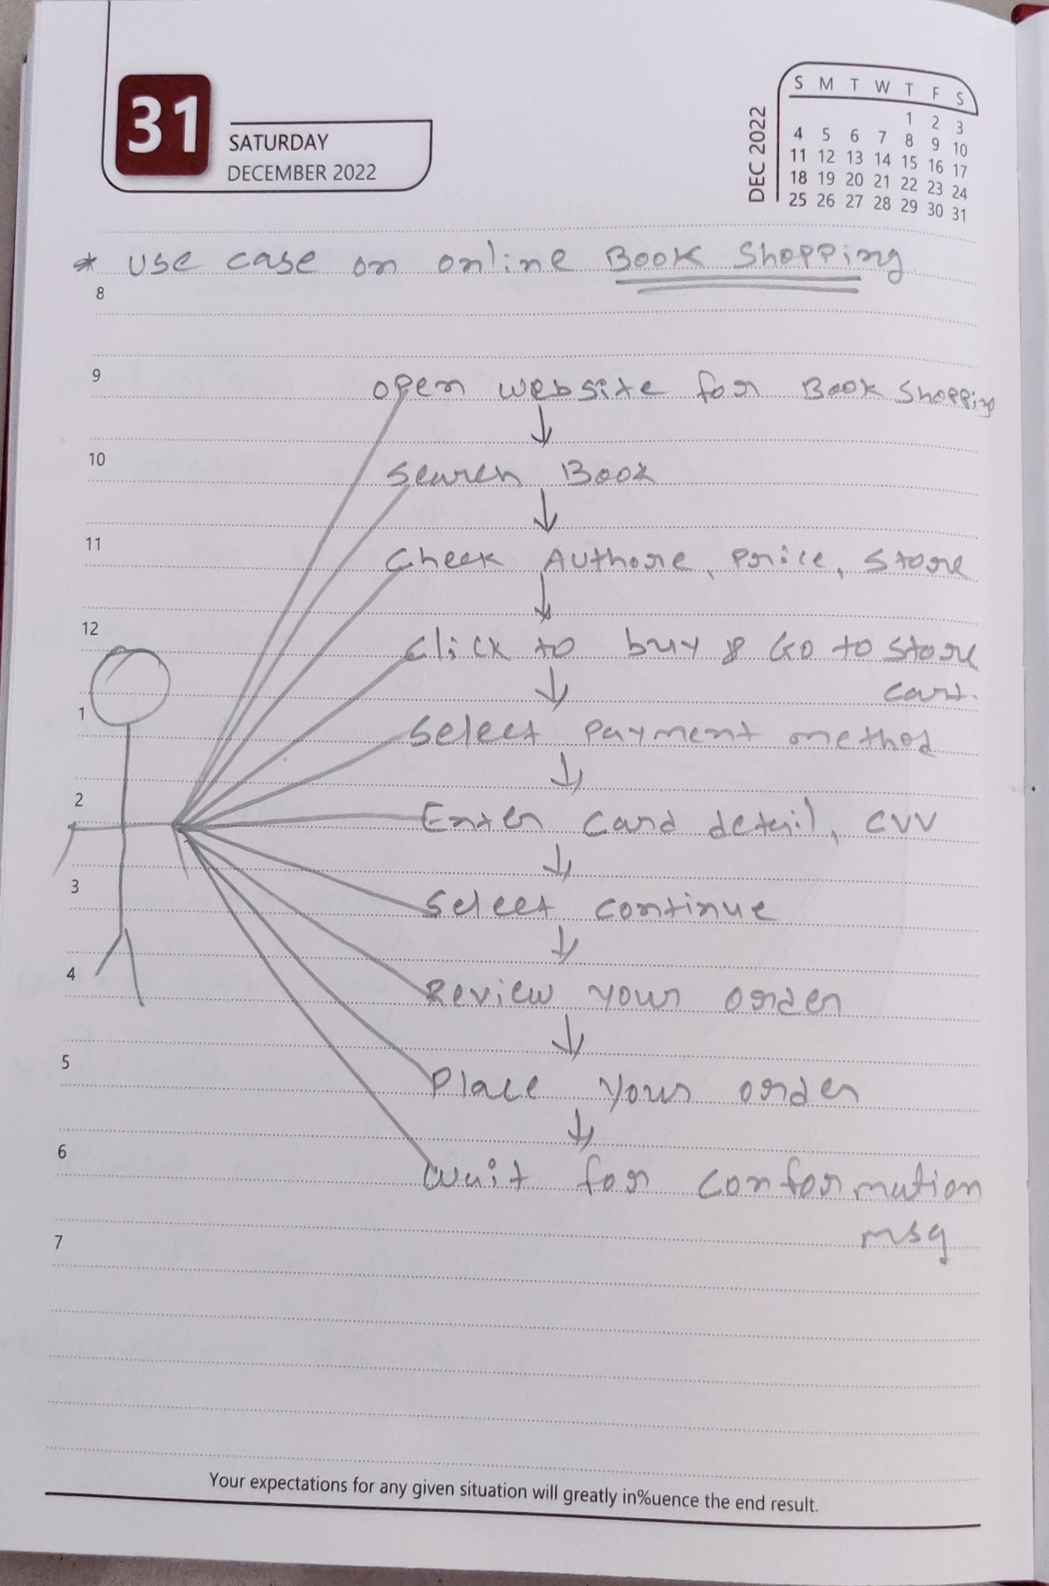

* Draw Use case on online bill payment system (paytm)

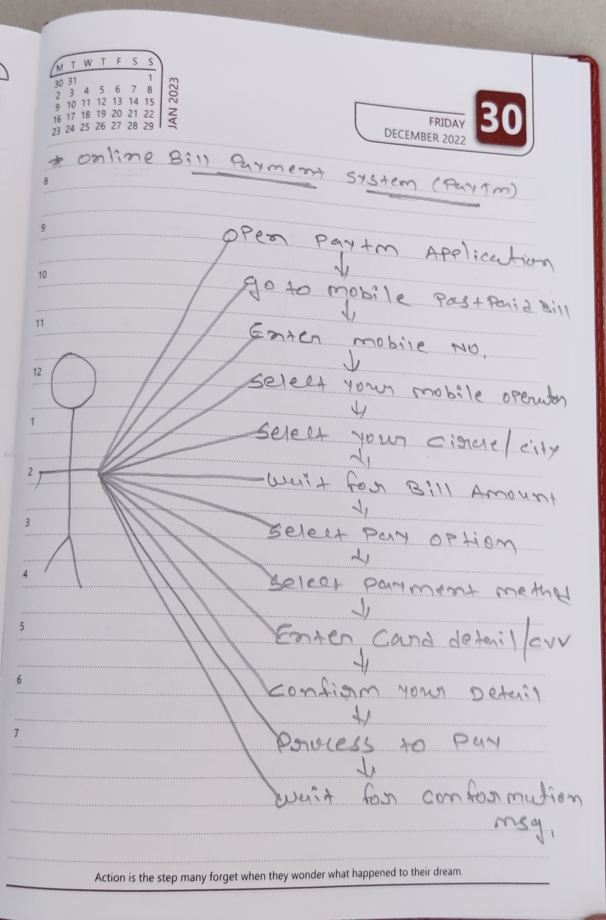

• Write SDLC phases with basic introduction

There are **6 phases** of SDLC & phases are as per below,

1. **Requirement collection / gathering. –** Features, usage scenarios, plan for change, functional and non-functional.
2. **Analysis –** The analysis phase define the requirement of the system, independent of how these requirement will be accomplished.
3. **Design –** Design architecture document, implementation plan, performance analysis, test plan.
4. **Implementation –** Given architecture document from design phase and required document from analysis phase the team should build exactly what has been required.
5. **Testing –** Testing simply stated Quality is very important, Regression testing, Internal testing, Unit testing, Application testing, Stress testing.
6. **Maintenance –** Software maintenance is one of the activities in software engineering & is the process of enhancing and optimizing deployed software as well as fixing defects.

• Explain Phases of the waterfall model

There are **06 phases** of water fall model,

1. Requirement collection / gathering.
2. Analysis.
3. Design.
4. Implementation.
5. Testing.
6. Maintenance.

• Write phases of spiral model?

There are **4** **Phases** of spiral model

1. Planning.
2. Risk Analysis.
3. Engineering.
4. Customer Evaluation.

• Write agile manifesto principles.

There are **4 types** of agile manifesto principles,

1. Individuals & Interactions.
2. Working software.
3. Customer collaboration.
4. Responding to change.

• What is join?

A join clause is used to combine rows from two or more tables based on a related column between them.

• Write type of joins.

There are **4 types** of join,

1. Inner join.
2. Left outer join.
3. Right outer join.
4. Full outer join.

• Explain working methodology of agile model and also write pros and cons?

Agile is a combination of iterative & incremental models with focus on process adaptability &

Customer satisfaction.

**Pros:-**

* Is a very realistic approach to software development.
* Resource requirement are minimum.
* Suitable for fixed or changing requirement.
* Delivered early partial working solution.

**Cons:-**

* Not suitable for handling complex dependencies.
* More risk for sustainability, maintainability.
* There is very high individual dependency, since there is minimum documented generation.

• Draw use case on Online shopping product using COD.

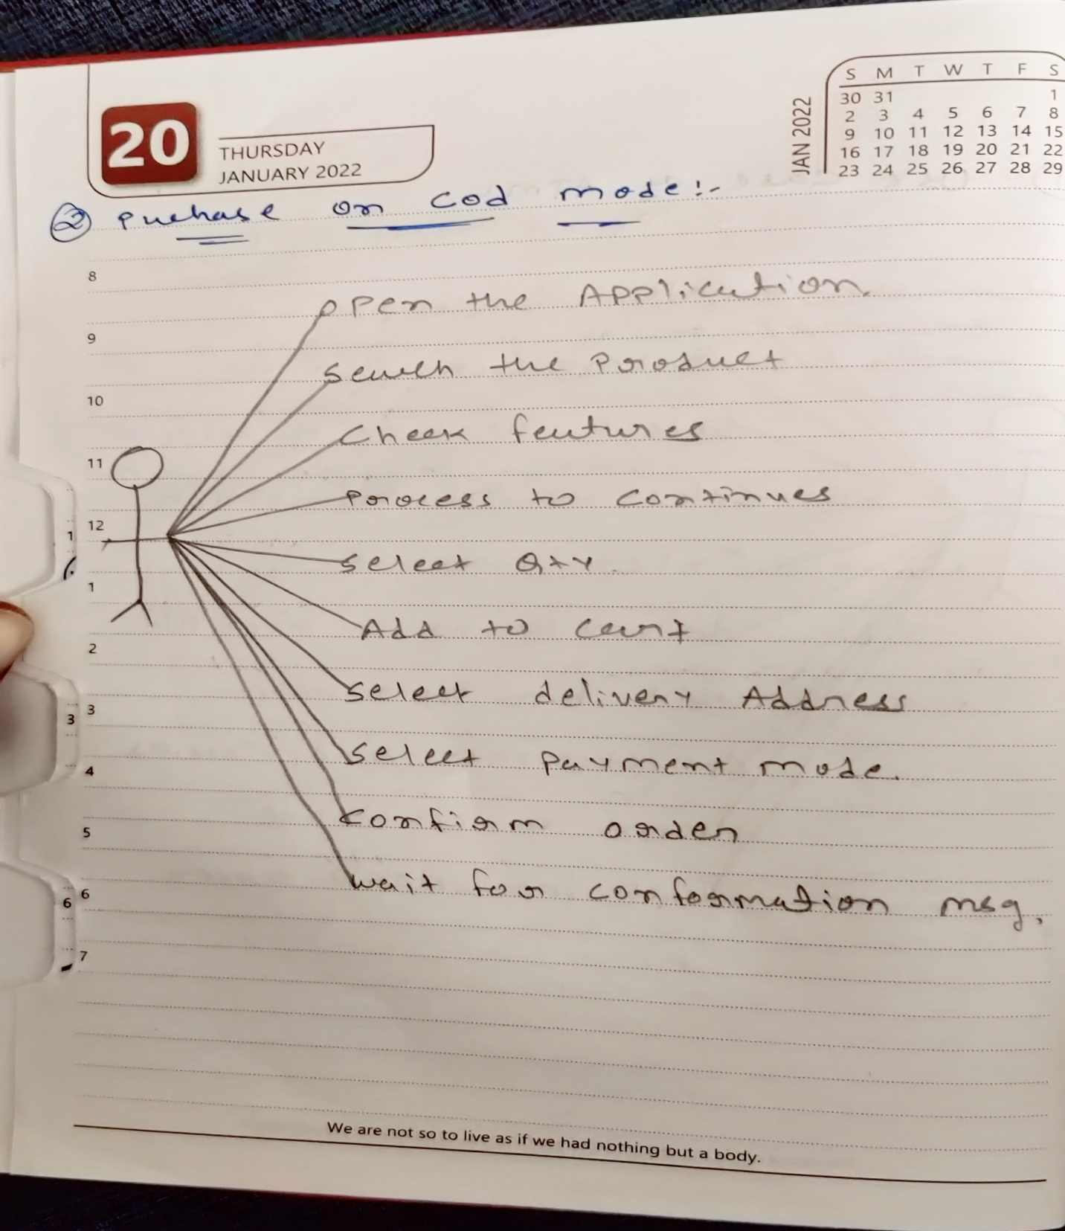

• Draw use case on Online shopping product using payment gateway

